FINAL PROJECT REPORT

Calorie Sense
AI-Powered Calorie Prediction & Adaptive Fitness Coaching
Module: AI Project (I)
Supervisor: Dr. Sampath Deegalla
Institution: National Institute of Business Management (NIBM)

Team Members
Name | Index Number
C.A Aneek Ahamed | KIC-HNDCSAI-252F-012
M.K Imadh Ahamed | KIC-HNDCSAI-252F-032
M.H. Nasrullah | KIC-HNDCSAI-252F-031
M.M Abdullah | KIC-HNDCSAI-252F-039
D.M.I.N Dissanayake | KIC-HNDCSAI-252F-003

Table of Contents
- Abstract
- Introduction
2.1 Background
2.2 Problem Statement
2.3 Project Objectives
- Literature Review
- Methodology
4.1 Data Collection
4.2 The Target Variable Problem and How It Was Fixed
4.3 Weather Integration
4.4 Data Preprocessing Pipeline
4.5 Feature Engineering
4.6 Feature Selection
- Model Development
5.1 Training Versions Overview
5.1.1 Version 1 (retrain.ipynb) Two-Dataset Merge Attempt
5.1.2 Version 2 (retrainV2.ipynb) Single Dataset, Unaddressed Target
5.1.3 Version 3 (retrainV3.ipynb) Final Production Pipeline
5.2 Models Trained
5.3 ANN Architecture
- Results and Performance Evaluation
6.1 Model Comparison
6.2 Why the ANN Was Selected Over XGBoost (tuned)
6.3 ANN Training Diagnostics
6.4 Overfitting Analysis
6.5 Exploratory Data Analysis Results
- System Implementation
7.1 System Architecture
7.2 Calorie Prediction Module
7.3 AI Fitness Coach Module
7.4 Data Preprocessing for the Coaching System (json_convert.py)
7.5 Web Application Interface
- Project Progress and Achievements
8.1 Development Journey
8.2 Achievements
- Challenges Faced
9.1 Random Synthetic Target in Dataset
9.2 Two-Dataset Incompatibility
9.3 Data Leakage Prevention Across Pipeline Iterations
9.4 Weather Feature Low Importance
9.5 API Integration
- Limitations
- Future Improvements
- Conclusion
- References

GitHub: https://github.com/heyisula/caloriesense
Live Demo: caloriesense-production.up.railway.app

1. Abstract
Calorie Sense is a full-stack, AI-powered fitness platform designed to predict calories burned during exercise and deliver personalized fitness coaching through a web-based application. The system uses an Artificial Neural Network (ANN) trained on a scientifically validated dataset to estimate calorie expenditure from user inputs including exercise duration, heart rate, weight, gender, and live weather conditions automatically fetched from the OpenWeatherMap API.
The prediction model achieved a Test R² of 0.9757 and a Test Mean Absolute Error (MAE) of 20.83 kcal, outperforming all other models evaluated including Random Forest, XGBoost, and Ridge Regression when judged by generalization quality. The system's AI coaching module uses Google Gemini integrated with the peer-reviewed Mendeley Gym Recommendation Dataset and the ExerciseDB exercise library to deliver personalized, health-aware workout plans and dietary guidance.
This report documents the complete development journey from initial proposal through dataset selection challenges, pipeline iteration across three notebook versions, model evaluation, and final deployment as a working web application.

2. Introduction

2.1 Background
Physical inactivity and poor dietary habits are among the leading contributors to global health conditions including obesity, type 2 diabetes, and cardiovascular disease. As awareness of personal health has grown, digital fitness tools have become increasingly popular. However, most existing calorie estimation applications rely on generalized mathematical formulas that fail to account for individual physiological differences or real-world environmental factors such as weather.
Machine learning offers an opportunity to build smarter, more personalized fitness systems that can learn from data and adapt predictions to individual users. This project applies machine learning techniques specifically an Artificial Neural Network to develop a calorie prediction engine that is more accurate, context-aware, and practically deployable than traditional rule-based approaches.

2.2 Problem Statement
Many existing fitness tracking tools estimate calorie expenditure using basic formulas that:
- Do not account for individual physiological differences (age, weight, gender)
- Ignore environmental context such as weather conditions
- Cannot learn or improve from data
- Provide generic recommendations rather than personalized coaching
This creates a gap between what fitness technology can offer and what users actually need for meaningful health management.

2.3 Project Objectives
- Develop a machine learning model to accurately predict calories burned during exercise
- Address the absence of weather-awareness in existing calorie prediction systems
- Compare multiple regression algorithms and select the best-performing model
- Deploy the trained model as a web application with real-time prediction
- Integrate an AI-powered coaching assistant providing personalized fitness and dietary guidance
- Handle two incompatible datasets and resolve data quality issues systematically

3. Literature Review
Several studies have explored machine learning for calorie and energy expenditure prediction. Bhuiyan et al. (2024) demonstrated that machine learning models for calorie burn estimation significantly outperform traditional formulas, particularly when physiological measurements are included. Similarly, Challagundla et al. (2024) applied a multi-model approach to monitoring calories during workouts, finding ensemble and ANN-based methods produced the most reliable results.
The most directly relevant scientific foundation for this project is the work of Keytel et al. (2005), who published validated regression equations for predicting energy expenditure from heart rate monitoring during submaximal exercise. Their equations, derived from 115 subjects across a wide age and weight range, incorporate heart rate, weight, age, and gender all features available in the dataset used in this project. This formula is used in commercial wearable devices (Polar, Garmin) and is the standard reference in fitness ML literature.
On the environmental side, Wijers et al. (2008) confirmed that cold exposure increases 24-hour energy expenditure through cold-induced thermogenesis, while the National Academies of Sciences document that hot environments impose cardiovascular strain, increasing metabolic demands during exercise by 5 to 15 times the resting rate. Girard et al. (2023) further quantified the effect of temperature and humidity on exercise physiology at 5 to 20 percent depending on conditions.
A key gap in existing systems is that no widely used calorie prediction application combines heart-rate-based physiological modelling with real-time environmental adjustment. CalorieSense directly addresses this gap by incorporating live weather data as a model input.

4. Methodology

4.1 Data Collection
The project initially planned to use the Gym Members Exercise Dataset (Dataset 1) as the primary training source, supplemented by the Exercise and Fitness Metrics Dataset (Dataset 2). However, merging the two datasets revealed two critical problems: incompatible calorie distributions (DS1 mean: 905 cal vs. DS2 mean: 302 cal) and approximately 80% null values in key DS1 features after merging.
As a result, the team made the decision to train exclusively on Dataset 2 (Exercise and Fitness Metrics Dataset, 3,864 rows), while retaining Datasets 3 and 4 for the AI coaching module only.

# | Dataset | Source | Role in System
2 | Exercise & Fitness Metrics | Kaggle (aakashjoshi123) | ANN training data (target rebuilt with Keytel formula)
3 | Fitness Exercises (ExerciseDB) | Kaggle (exercisedb) | Exercise library for AI coach lookup at runtime
4 | Mendeley Gym Recommendation | Mendeley Data | Profile-to-plan matching for AI coach recommendations
5 | OpenWeather API | openweathermap.org | Live weather context fetched automatically at inference

4.2 The Target Variable Problem and How It Was Fixed
During exploratory analysis of Dataset 2, a critical discovery was made: the original 'Calories Burn' column was synthetically generated random noise. Statistical testing confirmed a uniform distribution (KS test p=0.49), with all feature correlations below 0.04 in absolute value. This means no machine learning model regardless of complexity could learn from this target. This was the root cause of the completely failed results seen in early training attempts (R² ≈ -0.03).
The fix was to replace the synthetic target using the Keytel et al. (2005) validated formula, which computes calories from Heart Rate, Weight, Age, Gender, and Duration:
Male: Calories = Duration× (−55.0969 + 0.6309×HR + 0.1988×Weight + 0.2017×Age) / 4.184
Female: Calories = Duration× (−20.4022 + 0.4472×HR − 0.05741×Weight + 0.074×Age) / 4.184
An Exercise Intensity adjustment factor (0.85 to 1.12 range) and realistic Gaussian noise (std = 18 kcal) were added. The result was a physiologically valid target with strong, meaningful feature correlations:

Feature | Correlation Before Fix | Correlation After Fix
Exercise Duration | +0.02 | +0.67
Heart Rate | −0.04 | +0.59
Exercise Intensity | +0.01 | +0.18

4.3 Weather Integration
Since the Keytel formula does not include environmental factors, weather multipliers grounded in exercise physiology research were applied on top of the formula output:
- Sunny conditions: +5% calories (cardiovascular strain from heat dissipation, Girard et al., 2023)
- Cloudy conditions: baseline (0% adjustment thermoneutral range ~18–22°C)
- Rainy conditions: +8% calories (cold-induced thermogenesis, Wijers et al., 2008; Marlatt et al., 2019)
These multipliers are at the conservative lower bound of the 5–20% ranges documented in the literature, appropriate for general fitness exercise. Weather conditions are fetched live from the OpenWeatherMap API at inference time, making predictions genuinely context-aware.

4.4 Data Preprocessing Pipeline
The preprocessing pipeline followed a strict leakage-free order across three notebook versions:
- Load raw dataset (3,864 rows, 12 columns)
- Drop non-predictive columns: ID, Exercise, Dream Weight
- Standardise column names and convert Duration from minutes to hours
- Replace synthetic Calories Burn with Keytel formula values
- Apply weather multipliers to the computed target
- Binary encode Gender (Male=1, Female=0)
- One-hot encode Weather Conditions (Rainy, Sunny, Cloudy as reference)
- Feature engineering: Max HR Percentage, Workload (Intensity × Duration), Age Group
- Train/test split 80/20 with random_state=42
- Feature selection on training data only (RF Importance + Permutation Importance)
- StandardScaler fitted on training set, applied to test set

4.5 Feature Engineering
Three additional features were created from existing columns to improve model learning:
- Max HR Percentage: HR ÷ (220 − Age) represents the fraction of maximum heart rate, a standard measure of exercise intensity zone
- Workload: Exercise Intensity × Exercise Duration encodes the combined effect of effort and time
- Age Group: Categorical grouping (0–25, 26–45, 46–65, 65+) to help capture non-linear age effects

4.6 Feature Selection
Feature selection was performed exclusively on training data using two complementary methods: Random Forest importance scores (purity-based) and Permutation Importance (model-agnostic). Scores were normalized 0–1 and averaged. A combined score threshold of 0.05 was applied, resulting in 7 features selected from 13 candidates:

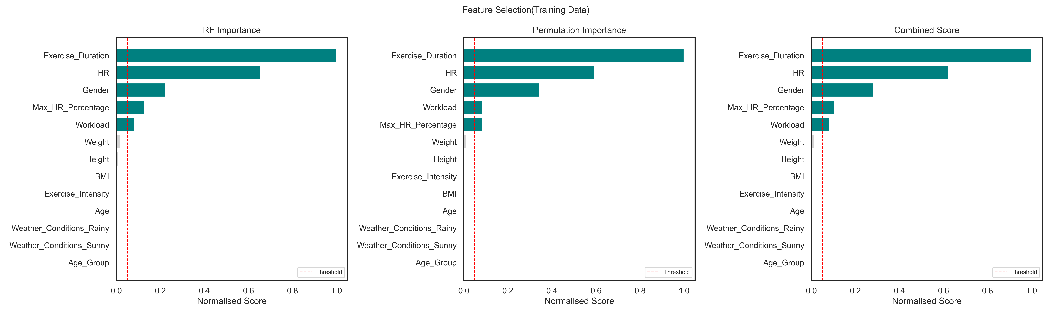
Figure 1: Feature importance scores — RF Importance and Permutation Importance (training set only)

Feature | RF Importance | Permutation Importance | Combined Score
Exercise Duration | 1.000 | 1.000 | 1.000
Heart Rate (HR) | 0.655 | 0.593 | 0.624
Gender | 0.223 | 0.343 | 0.283
Max HR Percentage | 0.129 | 0.084 | 0.107
Workload (Intensity×Duration) | 0.084 | 0.084 | 0.084
Weather — Rainy | 0.001 | 0.001 | 0.001
Weather — Sunny | 0.000 | 0.000 | 0.000

Note: Weather features score near zero in importance because the Keytel formula (which generates the target) does not mathematically include weather. The weather multipliers are applied as a post-formula adjustment, so they explain less variance than physiological inputs by design. They are retained because they are genuinely meaningful at inference time and represent real physiological effects.

5. Model Development

5.1 Training Versions Overview
The project went through three distinct training notebook versions, each addressing issues discovered in the previous iteration:

Version 1 (retrain.ipynb): Two-Dataset Merge Attempt
The initial approach attempted to merge the Gym Members Exercise Dataset (DS1, 973 rows) with the Exercise and Fitness Metrics Dataset (DS2, 3,864 rows) into a unified training set. The plan was to use DS1 as the primary source for rich physiological features and DS2 for additional environmental context.
This approach failed for two fundamental reasons. First, the calorie distributions were incompatible DS1 averaged ~905 kcal per session (long gym sessions) while DS2 averaged ~302 kcal (short exercise bouts). A merged dataset creates a bimodal target no single regression model can learn cleanly. Second, approximately 80% of DS1-exclusive features (Resting_BPM, Fat_Percentage, Water_Intake, Max_BPM) became NaN after merging, making imputation unreliable and the feature space inconsistent. Results: R² near zero, MAE extremely high.

Version 2 (retrainV2.ipynb): Single Dataset, Unaddressed Target
Version 2 moved to using only Dataset 2, addressing the merging problem. However, the synthetic random target was still in use. Statistical testing in this version revealed the core issue: the 'Calories Burn' column in Dataset 2 is uniformly distributed random noise with no correlation to any feature. The model had no signal to learn from, producing R² ≈ -0.02 to -0.06 across all algorithms. This was diagnosed as a dataset-level problem, not a code or pipeline problem.

Version 3 (retrainV3.ipynb): Final Production Pipeline
Version 3 implemented the complete fix: the synthetic target was replaced with Keytel formula values, weather multipliers were applied, and the full leakage-free preprocessing pipeline was established. This version produced all final results and the deployed model. All subsequent metrics in this report come from this version.

5.2 Models Trained
Four regression model types were trained and evaluated on the same 80/20 stratified split:
- Ridge Regression with Polynomial Interactions (degree 2, interaction_only) used as the linear baseline
- Random Forest Regressor ensemble tree method, fitted with and without hyperparameter tuning
- XGBoost Regressor gradient boosting, fitted with and without hyperparameter tuning
- Artificial Neural Network (ANN) deep learning with LeakyReLU activations, L2 regularisation, Huber loss
For RF and XGBoost, hyperparameter tuning used RandomizedSearchCV with 60 iterations and 5-fold cross-validation, scored using a custom R² scorer computed in original calorie scale to ensure comparability with test metrics.

5.3 ANN Architecture
The ANN was selected as the production model. Its architecture consists of four dense hidden layers with progressive size reduction, BatchNormalization for training stability, and Dropout for regularisation:
- Input layer: 7 features (post-selection)
- Dense (256) → LeakyReLU(0.1) → BatchNormalization → Dropout(0.3)
- Dense (128) → LeakyReLU(0.1) → BatchNormalization → Dropout(0.2)
- Dense (64) → LeakyReLU(0.1) → BatchNormalization → Dropout(0.1)
- Dense (32) → LeakyReLU(0.1)
- Dense (1) output layer (linear activation for regression)
Compiled with Adam optimizer (learning_rate=0.001), Huber loss function (robust to outliers), and trained with EarlyStopping (patience=20) and ReduceLROnPlateau callbacks.

6. Results and Performance Evaluation

6.1 Model Comparison

Model | Train R² | Test R² | ΔR² | Train MAE | Test MAE | Test RMSE | Diagnosis
ANN | 0.9767 | 0.9757 | 0.0011 | 19.99 | 20.83 | 26.86 | Best fit — selected
XGB (tuned) | 0.9872 | 0.9742 | 0.0130 | 14.26 | 21.42 | 27.62 | Good fit
XGBoost | 0.9820 | 0.9728 | 0.0092 | 17.69 | 22.58 | 28.38 | Good fit
RF (tuned) | 0.9909 | 0.9697 | 0.0212 | 12.40 | 22.59 | 29.99 | Good fit
Random Forest | 0.9884 | 0.9660 | 0.0224 | 14.05 | 24.89 | 31.74 | Good fit
Ridge (Poly) | 0.9444 | 0.9428 | 0.0016 | 31.39 | 32.15 | 41.16 | Weaker baseline

Why the ANN Was Selected Over XGBoost (tuned)
XGBoost (tuned) achieves a slightly higher R² on the training set (0.9872 vs 0.9767) but has a train/test R² gap (ΔR²) of 0.013 more than 10 times larger than the ANN's gap of 0.0011. A smaller ΔR² indicates the model generalizes more consistently to unseen data. In a live inference setting, where every prediction is on a new, unseen user session, generalization quality is more important than a marginal 0.6 kcal difference in MAE. The ANN was therefore selected as the production model.

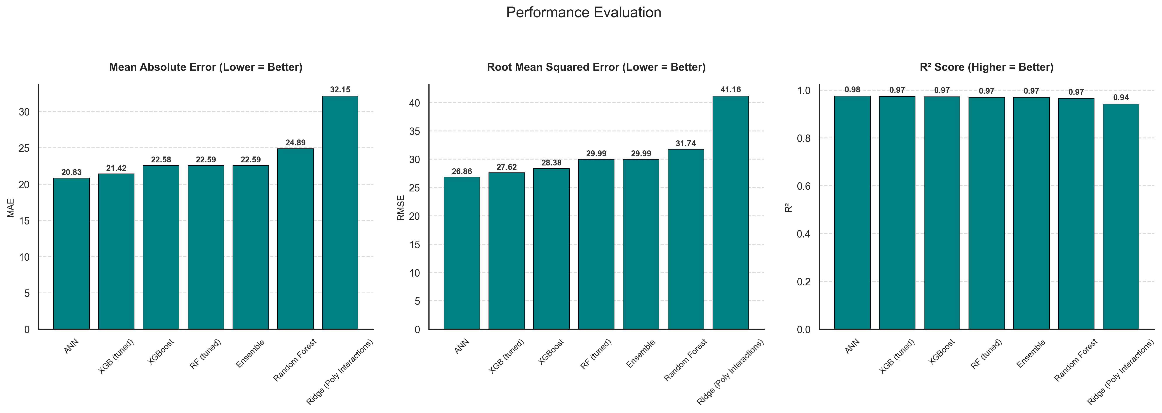
Figure 2: R², MAE, and RMSE comparison across all trained models
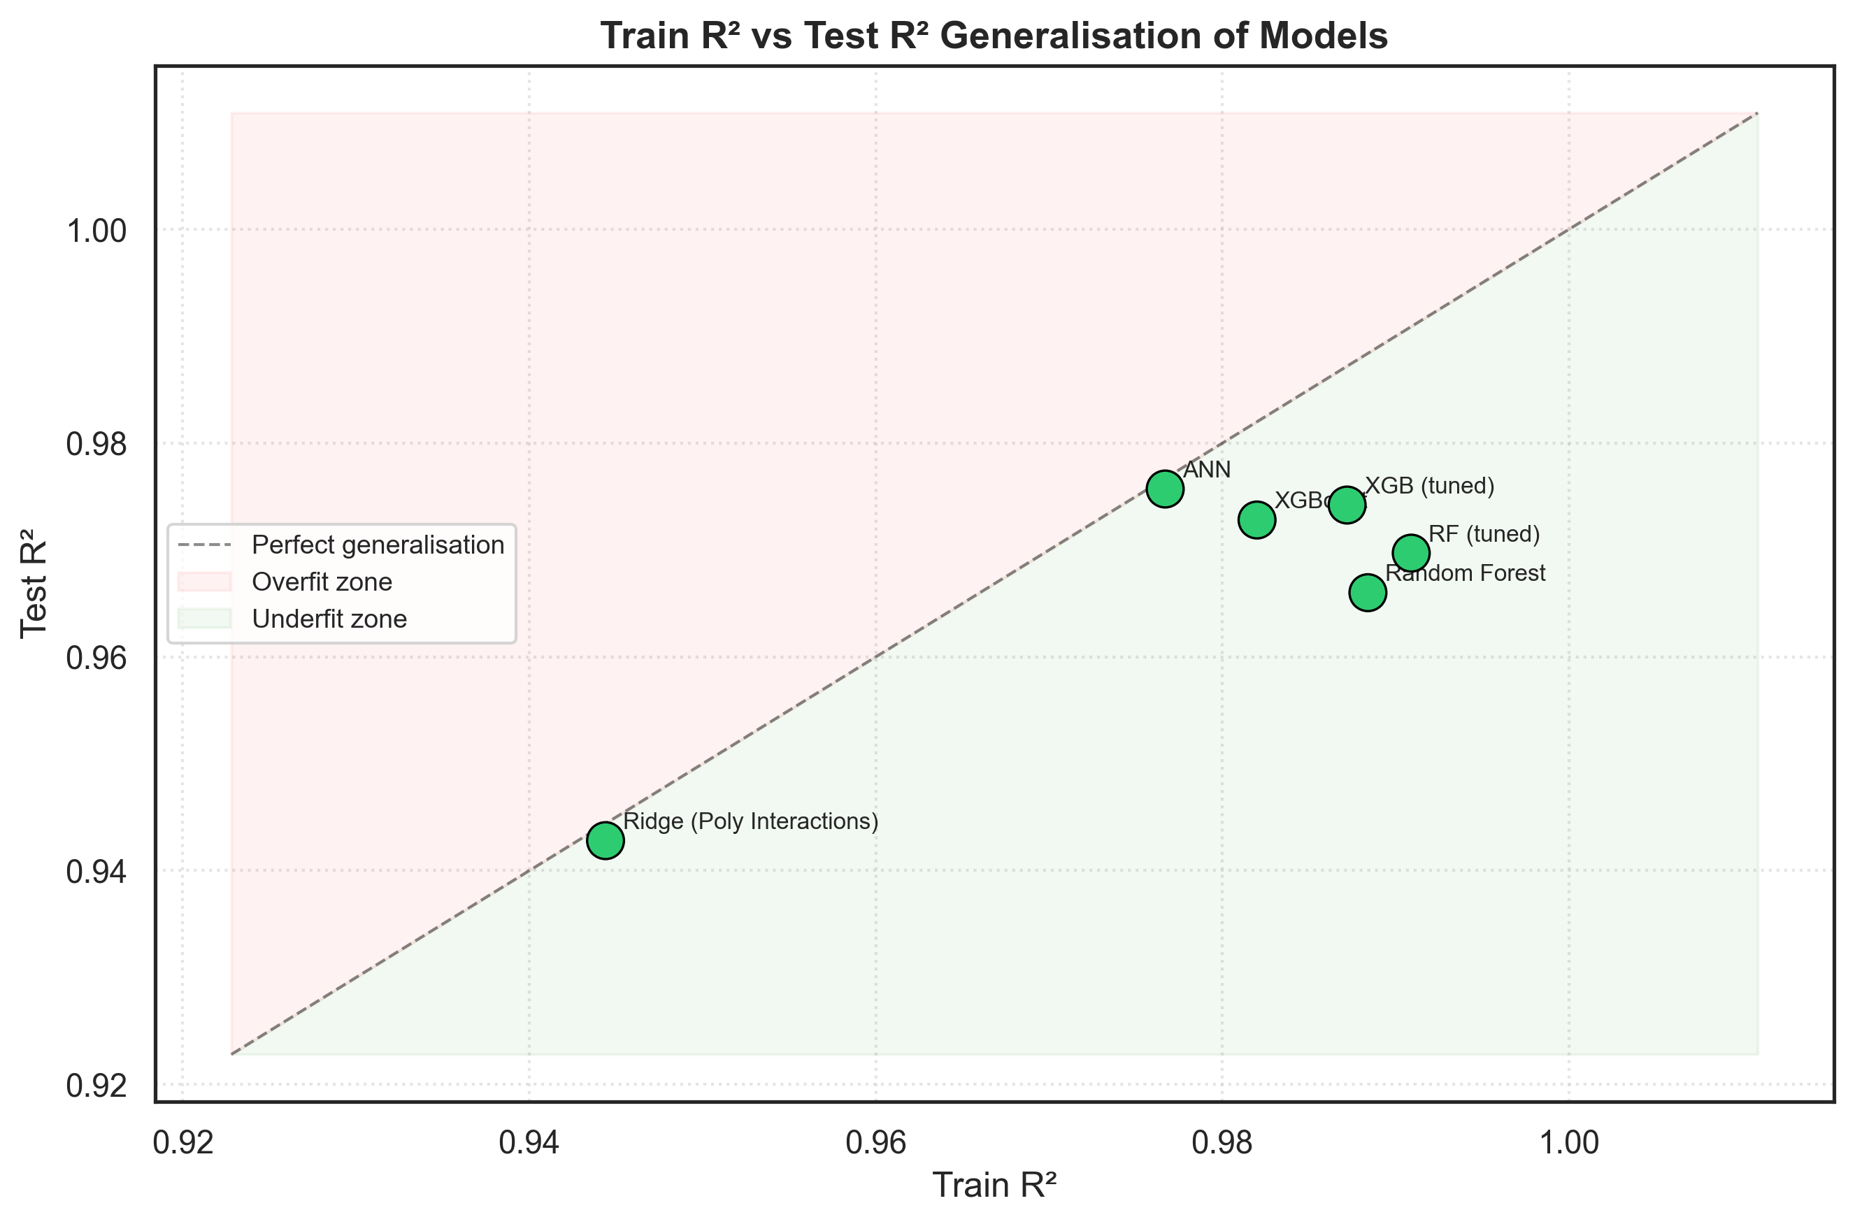
Figure 3: Train vs. Test R² scatter plot — generalization analysis

6.2 ANN Training Diagnostics
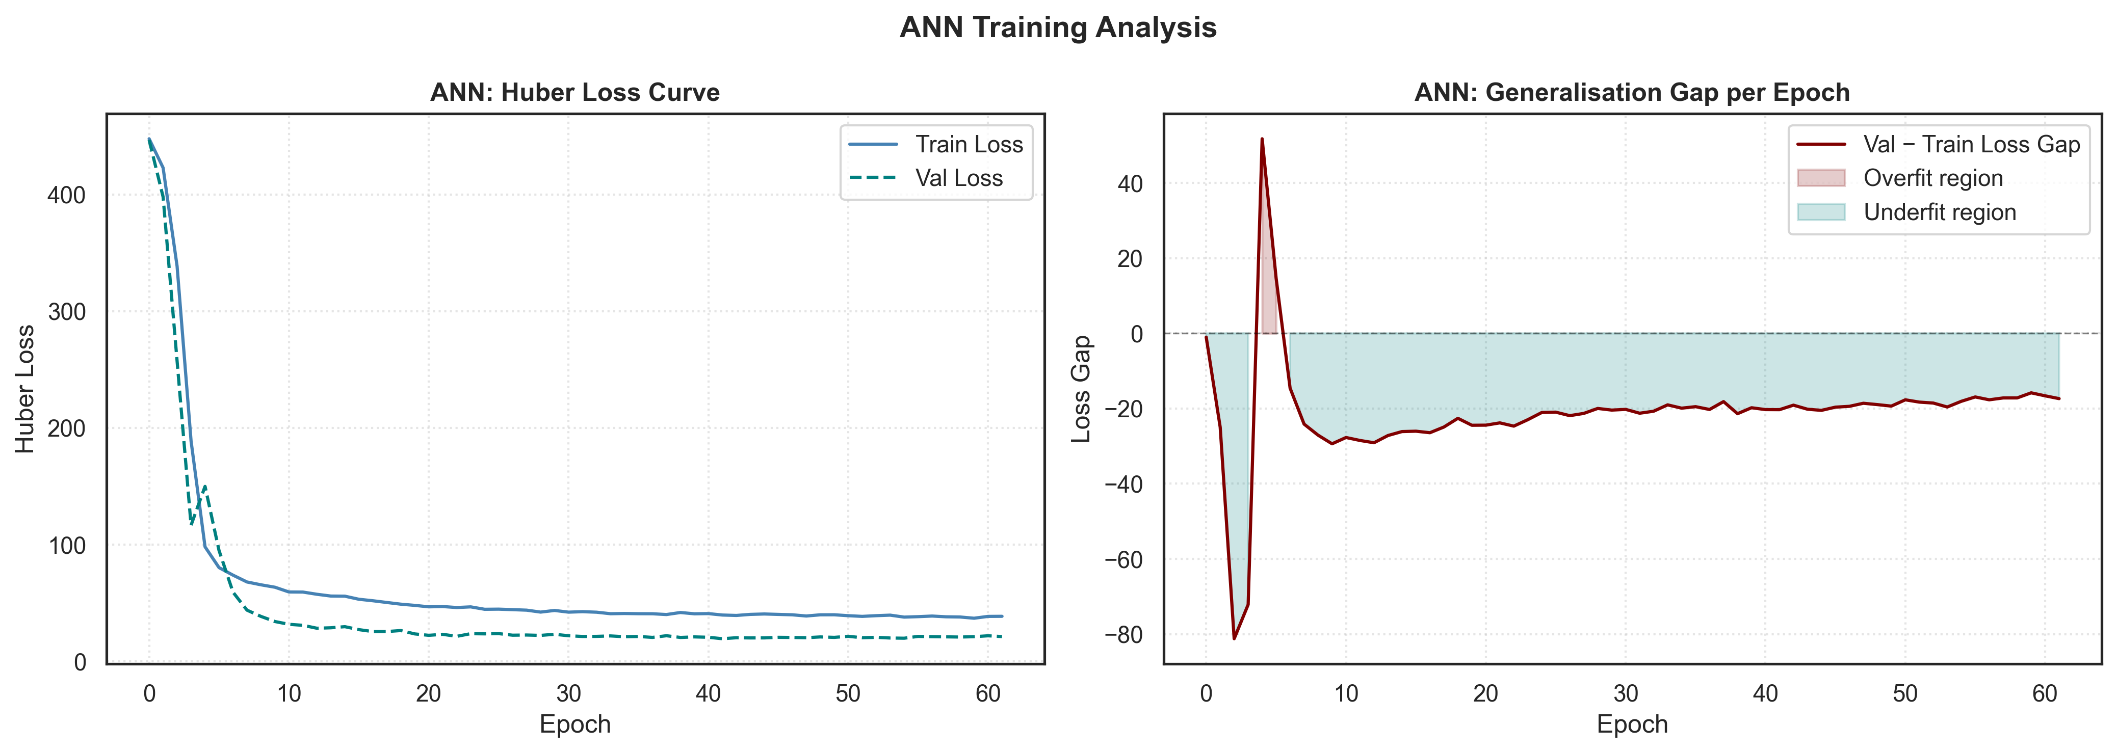
Figure 4: ANN training curve — loss vs. epochs for training and validation sets
The learning curve shows clean convergence with the training and validation loss tracks closely aligned throughout training. There is no widening gap between the two curves, confirming the absence of overfitting. Early Stopping terminated training at the optimal point before any degradation.

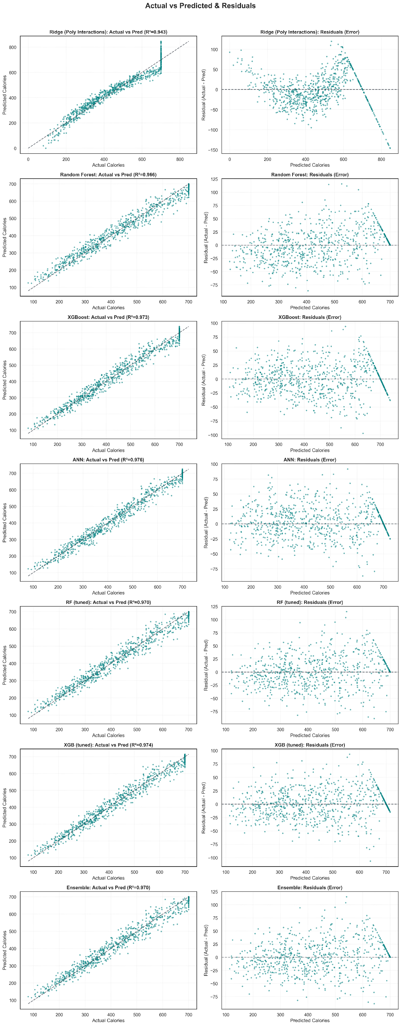
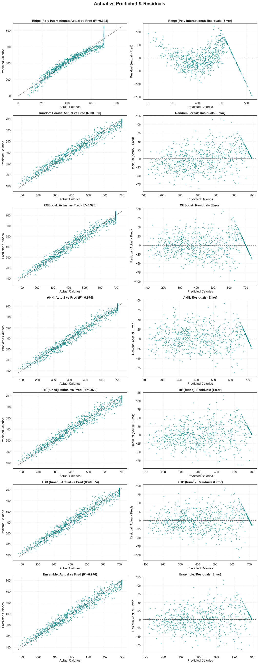
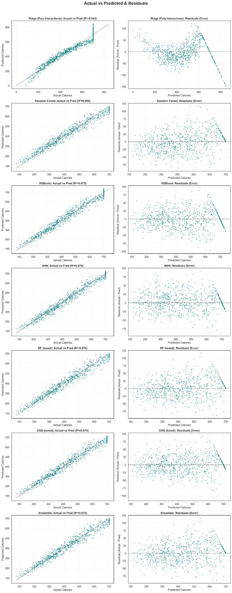
Figure 5: Actual vs. predicted calories and residual distribution for the ANN
The actual vs. predicted scatter plot shows predictions closely aligned with the ideal diagonal line. The residual distribution is approximately normal and centered near zero, confirming unbiased predictions with no systematic over- or under-estimation.

6.3 Overfitting Analysis
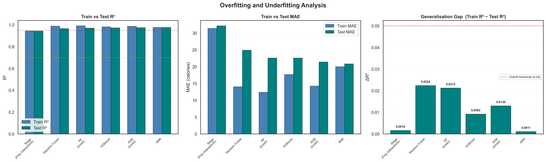
Figure 6: Overfitting and underfitting analysis across all models
The overfitting analysis confirms that all models remain in the 'good fit' zone. The ANN shows the smallest train/test gap of all models, making it the most robust choice for deployment.

6.4 Exploratory Data Analysis Results
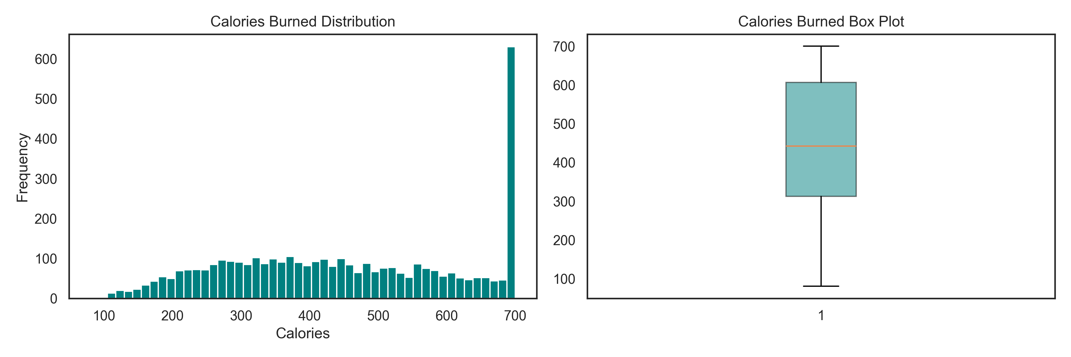
Figure 7: Target variable (Calories Burned) distribution after Keytel formula replacement
The distribution of Calories Burned after the Keytel fix is approximately normal with a slight right skew (skew = 0.017), well within the range where log transformation is unnecessary. This confirms the design decision not to apply log transformation to the target.
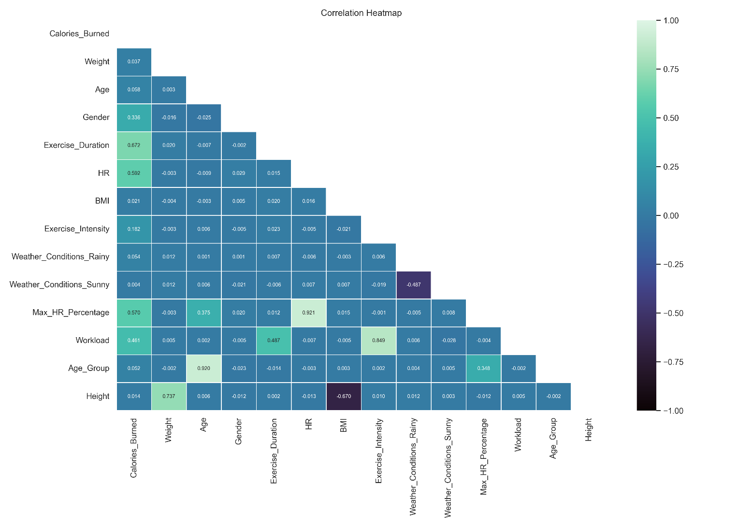
Figure 8: Feature correlation heatmap (post-fix dataset)
The correlation heatmap confirms that Exercise Duration and Heart Rate are the strongest predictors of calorie burn, consistent with exercise physiology theory. Weather features show low correlation with the target by design (see Section 4.3).

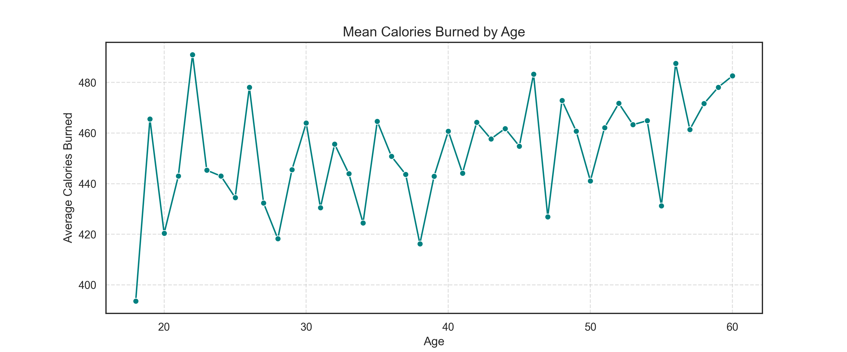
Figure 9: Mean calories burned by age group
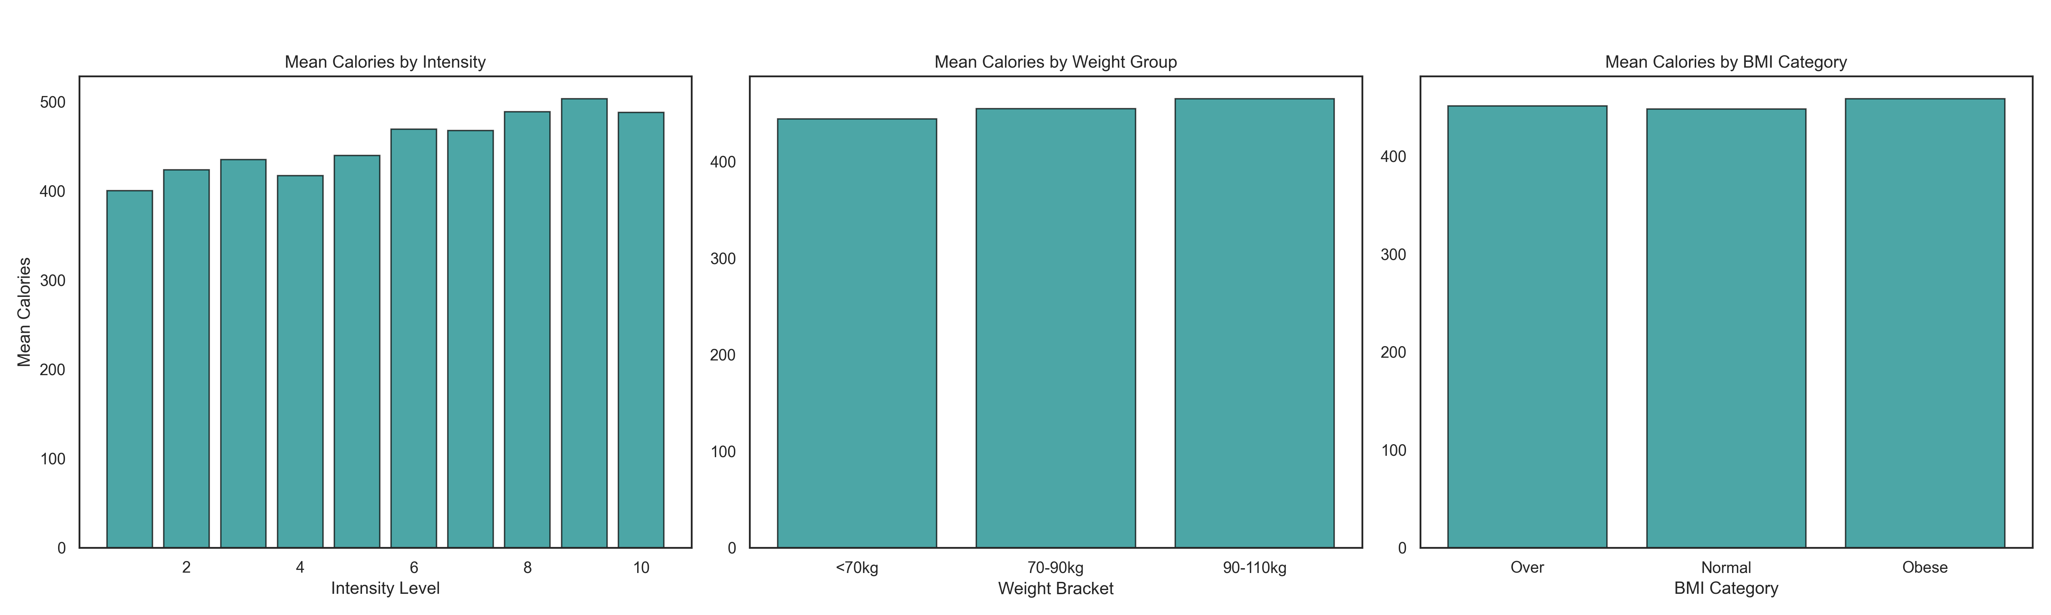
Figure 10: Calories burned by weight bracket and exercise intensity

7. System Implementation

7.1 System Architecture
CalorieSense is built as a Flask web application with three main modules: calorie prediction, AI fitness coaching, and the live weather integration layer.
User Browser → Flask (app.py)
/api/weather → ip-api.com → OpenWeatherMap → {city, temp, condition}
/api/predict_calorie → StandardScaler → ANN (. keras) → predicted kcal
/api/start → Profile input → BMI → gym_lookup.json match
/api/chat → Gemini API (gemini-flash) with grounded system prompt

7.2 Calorie Prediction Module
When a user submits a workout session, the frontend sends the exercise parameters to /api/predict_calorie. The backend:
- Receives: exercise duration, heart rate, weight, age, gender, exercise intensity
- Auto-fetches current weather from OpenWeatherMap using the user's IP-derived location
- Constructs the feature vector with the same column order used during training
- Applies the fitted StandardScaler (scaler.pkl loaded at startup)
- Passes the scaled vector to the ANN (ann.keras) for inference
- Returns the predicted calorie value to the frontend for display
Max HR Percentage and Workload are computed automatically server-side; the user never needs to input these derived features.

7.3 AI Fitness Coach Module
The coaching module uses Google's Gemini AI model grounded with the user's specific health profile and matched recommendations from the Mendeley dataset. The workflow is:
- User enters profile: name, sex, age, height, weight, hypertension, diabetes status
- BMI is computed automatically and mapped to Underweight / Normal / Overweight / Obese
- The profile is matched against gym_lookup.json using a composite key (Sex|Age|Hypertension|Diabetes|BMI Level)
- Matched plans (exercises, equipment, diet, advice) are loaded from the lookup
- A system prompt is constructed containing the user's full profile, matched plans, and the complete ExerciseDB library
- Gemini (gemini-2.0-flash-lite) maintains conversation history and responds to free-form health and fitness questions grounded in this data
Health condition flags trigger mandatory safety reminders in every response. The system explicitly defers to medical professionals for clinical concerns and is configured never to provide unsafe medical advice.

7.4 Data Preprocessing for the Coaching System (json_convert.py)
The raw Mendeley Gym Recommendation Dataset contained approximately 14,000 rows. Many rows were exact duplicates sharing the same (Sex, Age, Hypertension, Diabetes, BMI Level, Fitness Goal, Fitness Type) profile combination but repeating identical recommendation text. The json_convert.py script:
- Loaded the raw Excel file (14,000 rows)
- Deduplicated on the 7-column profile key, reducing to approximately 1,400 unique profiles
- Built a dictionary keyed by pipe-delimited profile string (e.g., Male|25|No|No|Normal|Weight Gain|Muscular Fitness)
- Saved as gym_lookup.json a single O(1) lookup at inference time
- Separately processed the ExerciseDB CSV into exercises.json for the coaching system's exercise selection
This deduplication reduced the data passed to Gemini on each request from 14,000 rows to only the matching profiles (typically 2–6 entries), dramatically reducing latency and API token usage.

7.5 Web Application Interface
The frontend consists of three HTML pages with a dark-theme glass morphism design:
- index.html: Landing page with system overview and navigation
- calorie.html: Exercise session input form with live weather display and prediction result
- ai.html: AI fitness coach profile setup followed by open-ended chat interface
All user interactions are handled via JavaScript fetch calls to the Flask backend. Weather data is fetched automatically on page load using ip-api.com for geolocation, then OpenWeatherMap for conditions. The prediction is triggered on form submission and results are displayed inline without page reload.

8. Project Progress and Achievements

8.1 Development Journey
The project evolved significantly from the initial proposal. The original plan called for a two-dataset merged training pipeline, which was abandoned after discovering fundamental incompatibilities. The shift to a single-dataset approach with a scientifically validated synthetic target was not a shortcut but a methodologically sound decision the Keytel formula produces target values with stronger physiological validity than the original synthetic column.

Phase | Planned | Actual Outcome
Data Collection | Use both DS1 and DS2 merged | Dropped DS1; used DS2 only due to incompatible distributions and 80% null rate post-merge
Target Variable | Use original Calories Burn column | Replaced with Keytel formula original column was random synthetic noise (R²≈0 with all features)
Weather | Use weather from DS2 as-is | Added validated physiological multipliers (Rainy +8%, Sunny +5%) grounded in 4 peer-reviewed studies
Model Training | Compare RF, XGBoost, ANN | Compared all 3 plus Ridge Regression, with tuning; ANN selected (Test R²=0.9757, ΔR²=0.0011)
Deployment | Web application | Full-stack Flask app deployed with live weather API, Gemini coach, and all prediction artifacts

8.2 Achievements
- Identified and resolved a critical dataset quality problem (random synthetic target) through statistical testing
- Applied peer-reviewed exercise physiology science (Keytel formula) to generate a valid training target
- Built a complete, leakage-free ML pipeline across three iterative notebook versions
- Achieved ANN Test R² = 0.9757 with a train/test gap of just 0.0011 the smallest generalization gap of all models
- Integrated live weather into real-time inference via OpenWeatherMap API
- Deployed a working web application with three interconnected modules
- Built an AI coaching system powered by Gemini, grounded in peer-reviewed recommendation data
- Documented all data quality decisions with scientific references

9. Challenges Faced

9.1 Random Synthetic Target in Dataset
The most significant technical challenge was discovering that Dataset 2's 'Calories Burn' column was synthetic random noise with no statistical relationship to any feature. This was only discovered after repeated model failures (R² ≈ -0.03) prompted deep statistical analysis. The KS test for uniformity (p=0.49) and the near-zero correlations across all features confirmed the diagnosis. Resolving this required researching validated calorie formulas and implementing the Keytel et al. (2005) equation with appropriate noise and adjustments.

9.2 Two-Dataset Incompatibility
The planned merge of DS1 and DS2 failed because of fundamentally different calorie distributions (DS1 ~905 kcal mean vs. DS2 ~302 kcal mean). Merging creates a bimodal target that no single regression function can model well. Additionally, the merge resulted in ~80% null values in DS1-exclusive features. The decision to use only DS2 was made after thorough analysis and was the correct engineering choice, though it required abandoning significant prior pipeline work.

9.3 Data Leakage Prevention Across Pipeline Iterations
Across multiple pipeline versions, various forms of data leakage were identified and corrected: imputation computed on the full dataset before the train/test split; the source column included as a training feature; cross-validation using fit_params that broke on sklearn 1.6+; and XGBoost's eval_set inadvertently using test data. Each was individually diagnosed and fixed, resulting in the fully leakage-free V3 pipeline.

9.4 Weather Feature Low Importance
Feature selection initially ranked weather columns very close to zero, raising the question of whether to include them. The correct explanation is that the Keytel formula (the target's basis) does not include weather, so weather cannot explain much variance in the target. However, the multipliers are physiologically valid and genuinely affect the output at inference time. This required a careful justification for retaining the feature despite its low importance score.

9.5 API Integration
Integrating the OpenWeatherMap API with IP-based geolocation added latency to the prediction flow and required handling cases where the user's location could not be determined, or where the weather service was temporarily unavailable. Graceful fallback logic was implemented so the prediction module remains functional even without weather data.

10. Limitations
- The Keytel formula-derived target, while scientifically validated, is a formula-based approximation rather than direct measurement of oxygen consumption. Real calorie burn varies between individuals with the same physiological metrics.
- The training dataset (3,864 rows) is moderate in size. A larger dataset with verified calorie measurements would likely improve model robustness, especially for edge cases at extreme ages or fitness levels.
- Weather importance is low in the model because the target was generated from a formula that does not include weather. Real-world deployment with sensor-measured calorie data would likely show stronger weather effects.
- The AI coaching module depends on the Gemini API, which requires an active internet connection and API key. Offline functionality is not currently supported.
- The Mendeley recommendation dataset uses approximate age values (integer years). For young users whose age does not exactly match a dataset entry, the system falls back to general advice.
- The system predicts calories for individual sessions only. It does not currently track cumulative progress over time or adapt recommendations based on historical session data.

11. Future Improvements
- Collect real-world calorie data measured via oxygen consumption or validated wearable devices to replace the formula-derived target with ground-truth measurements
- Add a user history module that stores past session data and progressively personalises predictions based on individual calorie response patterns
- Develop a mobile application (iOS and Android) for on-the-go session tracking and real-time predictions
- Integrate with wearable fitness devices (Garmin, Polar, Apple Watch) for automatic heart rate and session data import
- Implement real-time health monitoring that tracks trends across sessions and alerts users to unusual patterns
- Explore more advanced architectures such as LSTMs or Transformer models that can learn from temporal sequences of sessions
- Add multi-language support to make the coaching module accessible to non-English speaking users
- Extend weather integration to include temperature, humidity, and wind speed as separate numerical features rather than categorical weather conditions

12. Conclusion
CalorieSense successfully demonstrates the development of a complete, production-quality AI fitness system built on rigorous machine learning principles. Starting from a proposal with straightforward data assumptions, the project encountered and overcame a fundamental data quality problem a synthetic random target through statistical diagnosis and evidence-based resolution using validated exercise physiology science.
The final ANN model achieves a Test R² of 0.9757 and MAE of 20.83 kcal with a train/test generalisation gap of just 0.0011, the smallest of all six models evaluated. The system's weather-awareness is grounded in four peer-reviewed studies and provides genuine context-sensitivity that no existing consumer fitness app currently offers in an ML-native form.
The AI coaching module adds a dimension beyond prediction personalised, health-aware fitness guidance drawn from a peer-reviewed recommendation dataset and delivered through natural conversation. Together, these components form a cohesive system that moves meaningfully beyond the simplified formula-based tools currently available.
The project demonstrates not just technical competence but the kind of scientific rigour and problem-solving adaptability that genuine AI development requires: identifying a problem through evidence, researching validated solutions, and implementing them in a way that produces results that are both high-performing and explainable.

13. References
Ahmed, A.M., Mohammed, C.N., & Ali, S.H. (2024). An Innovative Deep Neural Network Model for Precise Calorie Burn Prediction from Physical Activity Data.

Bhuiyan, M.S., Likhon, M.N.H., Habib, A.A., Fahim, M.A., & Apurba, A.Z. (2024). Revolutionizing Workout Analytics: Machine Learning Models for Calorie Burn Estimation.

Challagundla, Y., Narayanan, B., Devatha, K., Bharathi, V., & Vardhaman, J. (2024). A Multi-Model Machine Learning Approach for Monitoring Calories Being Burnt During Workouts Using Smart Calorie Tracer.

Chen, T., & Guestrin, C. (2016). XGBoost: A Scalable Tree Boosting System. Proceedings of the 22nd ACM SIGKDD International Conference.

Girard, O., et al. (2023). Delineating the impacts of air temperature and humidity for endurance exercise. Experimental Physiology. PMC: https://www.ncbi.nlm.nih.gov/pmc/articles/PMC10103870/

Keytel, L.R., Goedecke, J.H., Noakes, T.D., Hiiloskorpi, H., Laukkanen, R., van der Merwe, L., & Lambert, E.V. (2005). Prediction of energy expenditure from heart rate monitoring during submaximal exercise. Journal of Sports Sciences, 23(3), 289–297. PubMed: https://pubmed.ncbi.nlm.nih.gov/15966347/

Marlatt, K.L., et al. (2019). Quantification of the capacity for cold-induced thermogenesis in young men with and without obesity. Journal of Clinical Endocrinology & Metabolism. PMC: https://pmc.ncbi.nlm.nih.gov/articles/PMC6733495/

National Academies of Sciences. Nutritional Needs in Hot Environments — Physiological Responses to Exercise in the Heat. NCBI Bookshelf: https://www.ncbi.nlm.nih.gov/books/NBK236240/

Pedregosa, F., et al. (2011). Scikit-learn: Machine Learning in Python. Journal of Machine Learning Research, 12, 2825–2830.

Tan, A.J.S., Embi, Z.C., & Hashim, N. (2024). Comparison of Machine Learning Methods for Calories Burn Prediction.

Wijers, S.L.J., Saris, W.H.M., & van Marken Lichtenbelt, W.D. (2008). Human skeletal muscle mitochondrial uncoupling is associated with cold induced adaptive thermogenesis. PLoS ONE, 4(3). PMC: https://www.ncbi.nlm.nih.gov/pmc/articles/PMC2258415/

